**AUSTRIA LANGUAGE**

**https://24x7offshoring.com/**

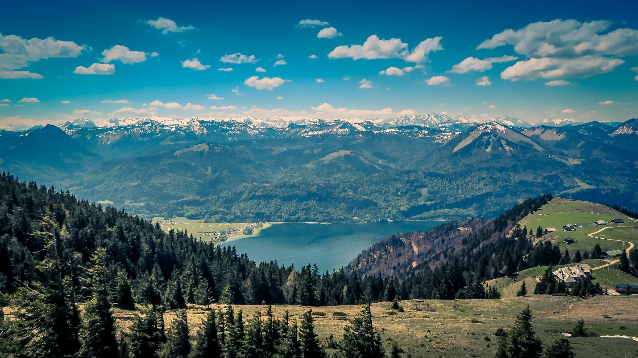[**http://24x7outsourcing.com/**](http://24x7outsourcing.com/)

**What Languages Are Spoken in Austria?**

The landlocked Central European nation of Austria (formally, the Republic of Austria) is home to an interesting combination of dialects. It is home to very nearly 9,000,000 individuals, a considerable lot of whom communicate in the country's true language, German.

Numerous Austrians additionally talk at least one Austro-Bavarian lingos, as we investigate in detail beneath.

Practically the entirety of Austria's populace – 98% – communicates in German, making it a pragmatic most widely used language, just as the country's true language.

Notwithstanding German, Austria is home to around 7,000,000 speakers of Austro-Bavarian, a gathering of Upper German dialects that are spoken the nation over, except for the government territory of Vorarlberg and a few spaces of Tyrol's Reutte District.

In those areas, occupants utilize an Alemannic tongue all things being equal. Austria is home to around 300,000 Alemannic speakers altogether.

German and Austro-Bavarian have affected each other throughout the long term yet are not a similar language.

**The Official Languages of Austria**

An assessment of the authority dialects of Austria doesn't take excessively long. In fact, the nation just has one: German. Nonetheless, Austria is additionally home to two huge (however informal) dialects: Austro-Bavarian and Alemmanic. Accordingly, no conversation of the language of Austria would be finished without conversation of each of the three.

**German**

What language is spoken in Austria? In true terms it is German.

The German expressed in Austria varies from Standard German, having been impacted by Austro-Bavarian. In any case, the two dialects (Austrian and Standard German, which is) are commonly understandable. To a great extent, at any rate.

Most would agree that provincial accents become an integral factor in certain pieces of Austria with regards to shared understandability.

The German expressed in Vienna, Austria's capital city, is a genuine illustration of this.

The German verbally expressed there has a lot about it that can demonstrate confusing to the individuals who speak Standard German, from the highlight to a portion of the jargon.

Such contemplations are significant for those giving German to English interpretation administrations according to German in Austria – and the other way around with this language matching.

While a Standard German-speaker could possibly wade through, a local Austrian German speaker will have a vastly improved potential for success of creating an exact, excellent interpretation.

Austria's semantic history is connected to its political history, similar to the case with such countless nations. Part of the Holy Roman Empire until 1806, Austria at that point turned out to be essential for the German Confederation.

**Austro-Bavarian**

With 13 million speakers altogether, Austro-Bavarian can be heard in the German province of Bavaria, in Switzerland, in Italy and in Hungary, just as in Austria. In Austria, it has more than 7,000,000 speakers.

The language began with the Bavarii, a Germanic clan with a duchy that spread from current Bavaria to parts of Austria in the early Middle Ages.

**Alemannic**

One more of the informal dialects of Austria, Alemannic is spoken by around 300,000 of the nation's occupants.

The language is slid from the Alemanni, an assortment of Germanic clans from the banks of the Upper Rhine, and is spoken in Switzerland, Germany, Liechtenstein, France, Italy, the US and Venezuela, notwithstanding Austria.

Altogether, Alemannic has around ten million speakers, however just a little level of them live in Austria.

**AUSTRIA LANGUAGE**

**https://24x7offshoring.com/**

**http://24x7outsourcing.com/**